Project Design Phase-II

Data Flow Diagram & User Stories

|  |  |
| --- | --- |
| Date | 19 October 2022 |
| Team ID | PNT2022TMID31081 |
| Project Name | Early Methods for Detection of Forest Fires |
| Maximum Marks | 4 Marks |

**Data Flow Diagrams:**

**Example:** [**(Simplified)**](https://developer.ibm.com/patterns/visualize-unstructured-text/)

Example: DFD Level 0 (Industry Standard)

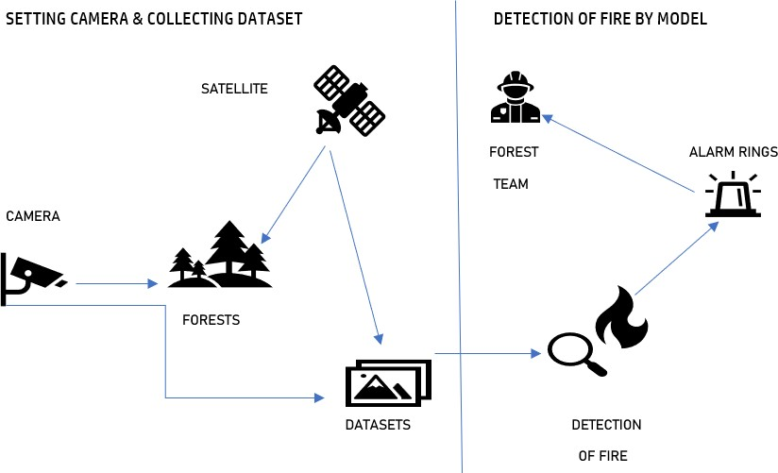 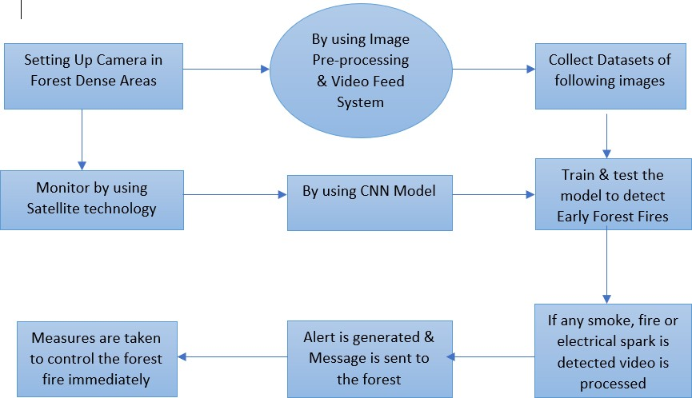

**User Stories**

|  |  |  |  |  |  |  |
| --- | --- | --- | --- | --- | --- | --- |
| **User Type** | **Functional Requirement**  **(Epic)** | **User Story Number** | **User Story / Task** | **Acceptance criteria** | **Priority** | **Release** |
| Forest Management  Team | Initializing Camera | USN-1 | As a user, the forest management team has to survey the forest by adding camera to the fire prone areas | The live video captured can be monitored | High | Sprint-1 |
|  |  | USN-2 | As a user, the forest management team can get video feed which is used for processing | The camera sends video or  image to the forest centre | High | Sprint-2 |
|  |  | USN-3 | Along with forest team, the NGO can also get  access of the video to take some early measurement of forest fires | They can also get the view  of the live monitoring of forest | Low | Sprint-1 |
| Technical Team | Image Classification | USN-4 | By using CNN Model, the images captured by the camera is classified accordingly by testing & training the model | The model should be able to identify the difference between fire and a normal  smoke | Medium | Sprint-2 |
|  | Using Open CV | USN-5 | The recorded video is under monitoring continuously to determine the detection of early video | Therefore, by using CNN we can determine the input layer, classify the hidden layers and send warnings  through output layer | High | Sprint-2 |
| Alert Team | Twilio API | USN-6 | Thus, after successful detection of fire by processing images. This, API sends the alert by buzzing the alarm and sends messages through chatbot | Thus, the immediate response which is required for earlier determination through sending quick  responses | High | Sprint-2 |
| Fire Management |  |  | They play the most important role to cool the  fire and manage the excess spread of fire further | They take the following  measures to stop fire from spreading | HIgh | Sprint-2 |
| Media & Nearby  Residing People | News, Radio,  Alerts, | USN-7 | Protecting wildlife, human from the disaster caused | Thus, helping unit should be sent to protect lives. | Medium | Sprint-2 |